SIMATS ENGINEERING
Saveetha School of Engineering
CSA0706 — Computer Networks
NAME:MANIYAM ANUSHKA(192525411)
Design and Evaluate a Smart Campus Network
Using Protocol Analysis, Network Topology and Simulation-Based Performance Metrics
Course Outcomes (CO) | CO3, CO4, CO5
Bloom's Taxonomy Level | L5 — Evaluate, L6 — Create
SDG Mapping | SDG 9 — Industry, Innovation and Infrastructure
Team Members | [Name 1 — Reg. No.] · [Name 2 — Reg. No.] · [Name 3 — Reg. No.]
Submission Mode | Google Classroom (report) + GitHub repository link

1. Problem Statement and Problem Formulation
A multi-campus university wants a single, unified network that reliably serves four functional zones — the Admin Block, the Academic Block, the Hostel Block, and a Server / Data Centre zone — connecting roughly 1000 end devices (staff and student PCs, laptops, lab servers, IP cameras, wireless clients, and IoT sensors). The assignment problem is to design, and then evaluate through simulation, four candidate topologies (Star, Mesh, Bus and Hybrid) that could realise this Smart Campus Network, and to identify which one performs best under normal, examination-peak, and failure conditions.
The core question this report answers is: given a fixed device population and four traffic conditions (normal academic use, peak online-examination load, and congestion / simulated link failure) carrying TCP, UDP, HTTP, DNS, FTP and ICMP traffic, which topology gives the best balance of throughput, delay, jitter, packet loss, response time, bandwidth utilisation, reliability, scalability and cost?

2. Objective and Expected Outcomes
- Design logical and physical Star, Mesh, Bus and Hybrid topologies for a 4-zone, 1000-device smart campus.
- Select appropriate networking devices, transmission media and cabling standards for each design.
- Model and simulate TCP, UDP, HTTP, DNS, FTP and ICMP traffic under three test conditions.
- Measure throughput, delay, jitter, packet loss, response time and bandwidth utilisation for every (topology × condition × protocol) combination, with repeated trials for reliability.
- Compare the four topologies quantitatively and recommend the most suitable architecture, with justification grounded in the measured evidence.
Expected outcome: a defensible, evidence-based recommendation of one primary topology (with a fallback) for the campus deployment, plus a documented, repeatable simulation methodology and artefact set (code, data, charts, diagrams) that satisfies the assignment's rubric criteria.

3. Requirements, Constraints and Assumptions

3.1 Requirements
- Connectivity for ≈1000 end devices across 4 zones with room for growth (scalability).
- Support for mixed traffic: bulk transfer (FTP), web (HTTP), transactional (TCP), real-time-ish (UDP), name resolution (DNS), and reachability testing (ICMP).
- Acceptable performance during a peak load event (all-hostel online examination) without service collapse.
- Tolerable degradation, not total outage, when a link fails.

3.2 Constraints
- Budget: cabling, device and licensing cost must be justified against the performance gained.
- Physical layout: buildings are geographically separated, ruling out a literal single shared bus for the whole campus at gigabit speeds.
- Time: the assignment must be completed and simulated within the 2-day submission window.

3.3 Assumptions
- Each zone is internally cabled with structured Cat6/Cat6a (100 m runs) or multimode fibre for inter-building backbone links.
- Devices are distributed roughly evenly across the four zones (≈250 devices per zone) with the Server/Data Centre zone hosting fewer end-user devices and more servers.
- Simulated results are produced by a parametric, queueing-theory-based Python model calibrated to the qualitative behaviour each topology is known to exhibit (see Section 6), used in place of / alongside a Packet Tracer or GNS3 emulation, since repeated, large-scale (1000-device) trials are impractical to hand-run interactively in a live simulator within the submission window.

4. Application of Relevant Course Knowledge
The design draws directly on CO3–CO5 course concepts: the OSI/TCP-IP layered model and protocol behaviour (TCP's reliability and flow control vs. UDP's low-overhead best-effort delivery; HTTP request/response semantics; DNS's small-packet, latency-sensitive lookups; FTP's large-payload throughput demands; ICMP's role in reachability/diagnostics); topology theory (fault domains, redundancy, single points of failure, shared-medium collision behaviour); structured cabling standards (TIA/EIA-568, 100 m copper limits, fibre for backbone runs); and performance-metric theory (Little's Law style relationships between load, delay and throughput; how jitter and loss compound under queueing congestion).

5. Design — Network Topologies, Devices, Media and Cabling
Four candidate designs were produced for the same 4-zone, 1000-device campus. Each keeps the same end-device population and zone boundaries so the topology itself is the only variable being compared.

5.1 Star Topology
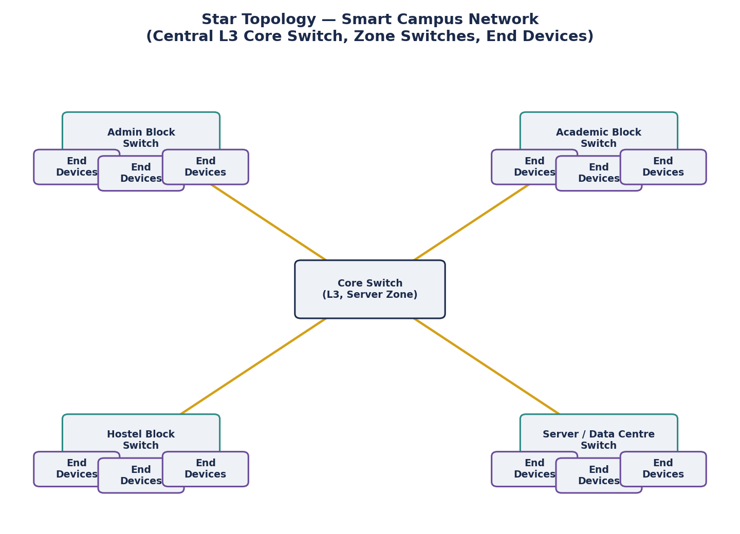
Figure 5.1 — Star topology: a Layer-3 core switch in the Server/Data Centre zone, with a dedicated Layer-2 zone switch (and its end devices) per building, connected back to the core over point-to-point Gigabit Ethernet / fibre uplinks.
- Devices: 1 core L3 switch, 4 zone L2 access switches, wireless access points per floor, edge firewall/router at the WAN edge.
- Media/cabling: Cat6a UTP (TIA/EIA-568-B) to end devices (≤100 m), single-mode fibre uplinks from each zone switch to the core (inter-building).
- Strength: simple to manage/troubleshoot, a single link failure only isolates one zone. Weakness: the core switch is a single point of failure for the whole campus.

5.2 Mesh Topology
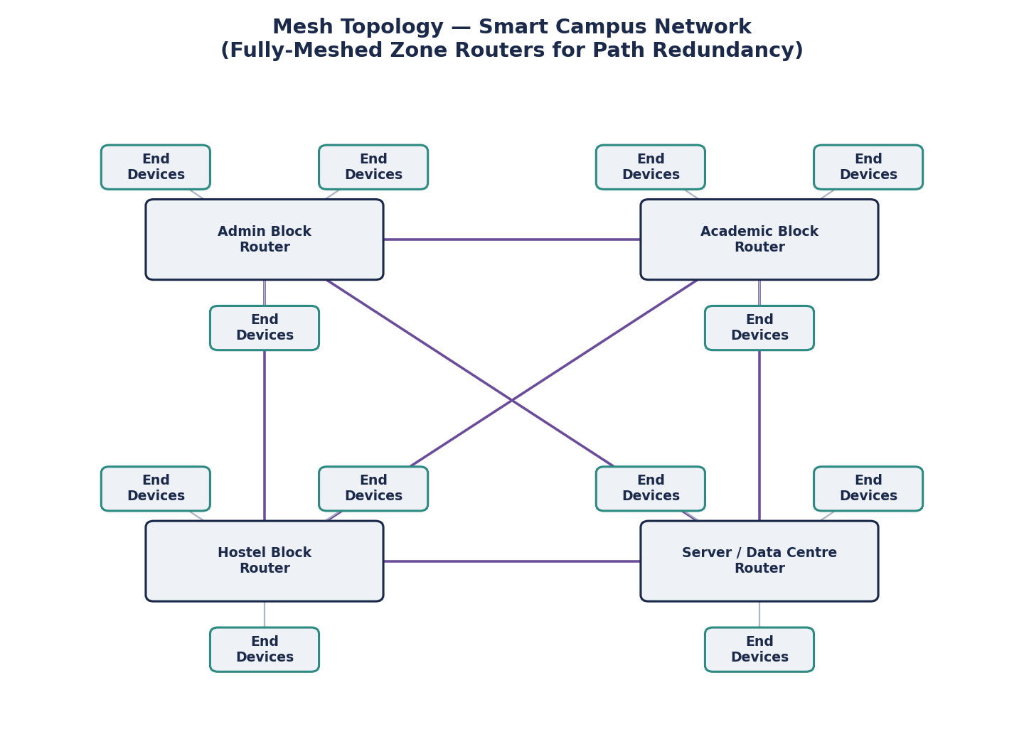
Figure 5.2 — (Partial/full) Mesh topology: a router at each zone, interconnected with redundant point-to-point links so that any zone can reach any other over more than one path.
- Devices: 4 zone-edge routers with routing protocol (e.g. OSPF) for path redundancy, plus the same per-zone access layer as the star design.
- Media/cabling: single-mode fibre backbone links between every pair of zone routers (6 links for a full mesh of 4 nodes), Cat6a to end devices.
- Strength: highest resilience — no single link or node failure isolates a zone. Weakness: highest cabling and device cost, most complex to configure and maintain.

5.3 Bus Topology
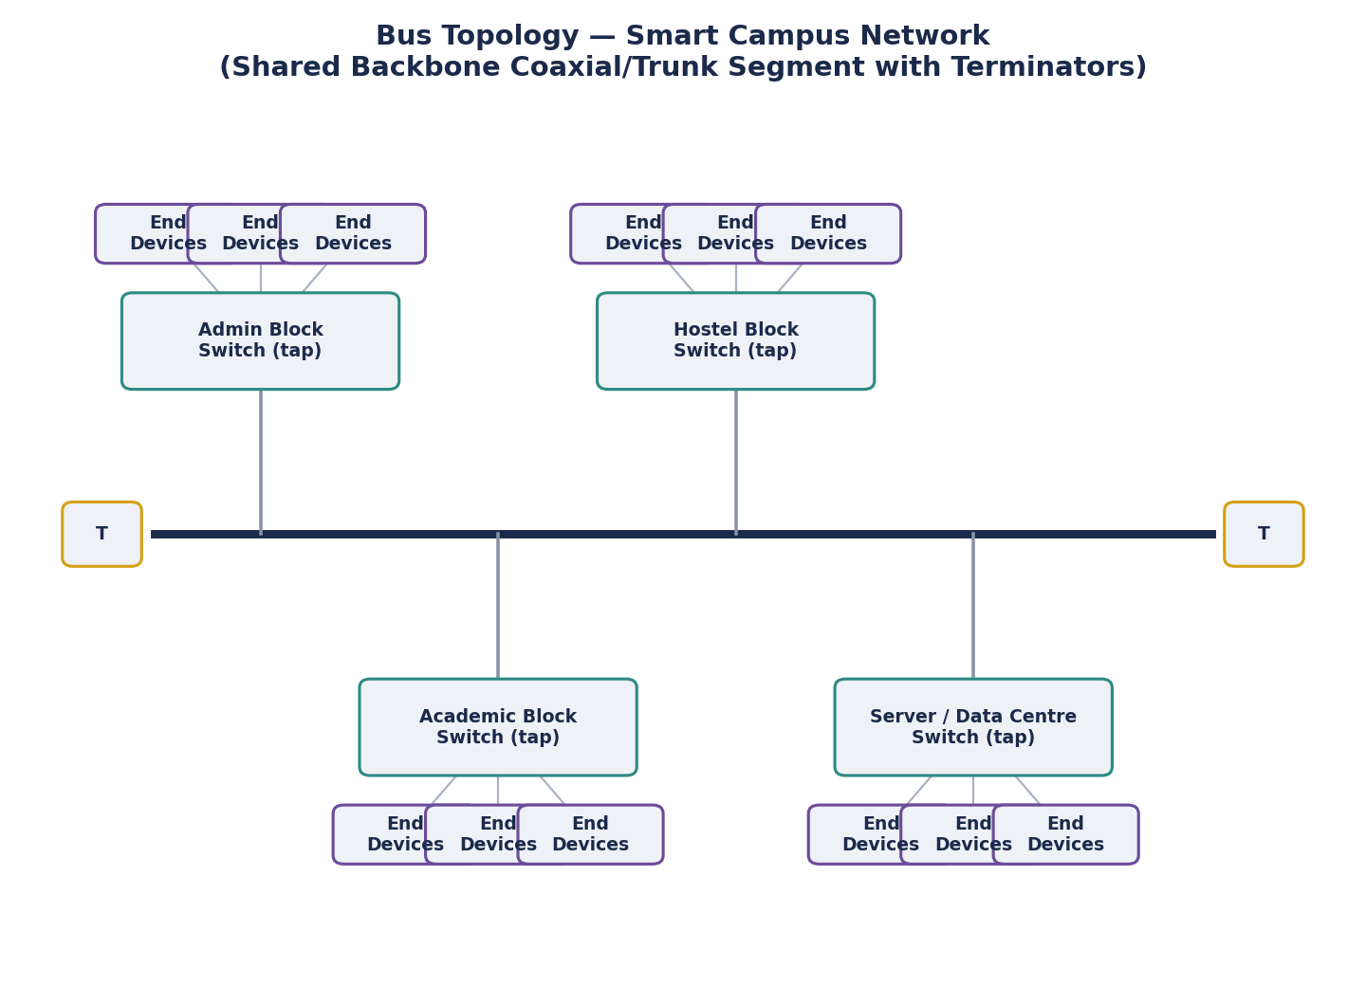
Figure 5.3 — Bus topology: all four zone switches tap into one shared backbone trunk terminated at both ends.
- Devices: 4 zone switches tapped onto a shared backbone segment with terminators; legacy coaxial (10BASE2/5-style) or a shared-medium Ethernet hub emulation in the simulator.
- Media/cabling: coaxial trunk (or a hub-based shared-collision-domain equivalent) for the backbone; Cat6 to end devices within a zone.
- Strength: lowest cabling cost. Weakness: a single backbone break can partition the whole campus; shared medium means collisions and congestion scale badly with 1000 devices — theoretically and structurally the weakest option for this deployment size.

5.4 Hybrid Topology (Recommended Baseline)
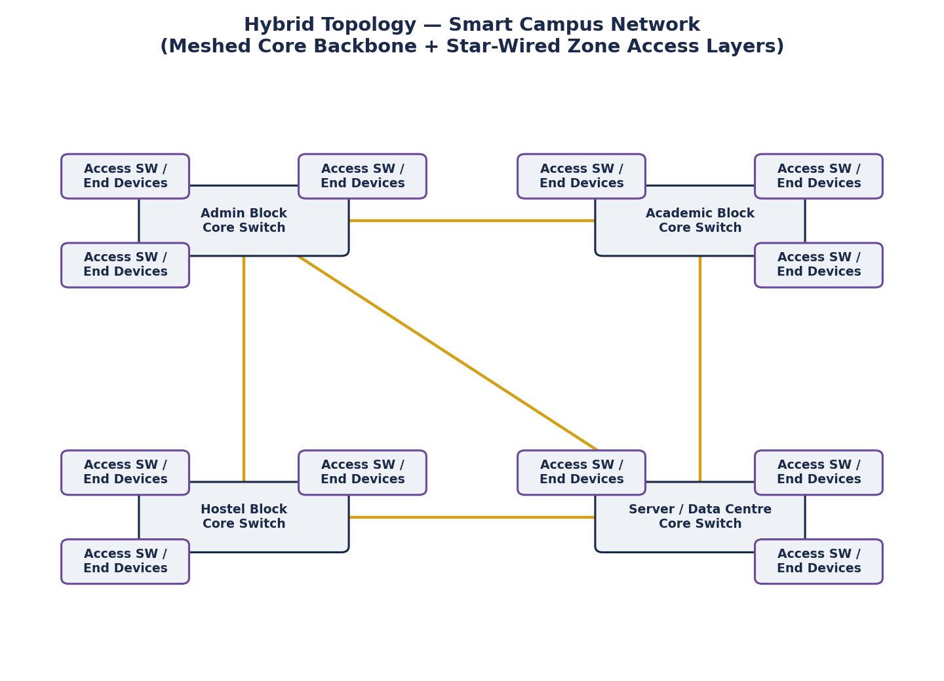
Figure 5.4 — Hybrid topology: a partially-meshed core backbone between the four zone core switches (for redundancy) with a star-wired access layer inside each zone (for simplicity and manageability).
- Devices: 4 zone core switches meshed with redundant fibre backbone links, each fanning out to star-wired access switches and end devices within the zone.
- Media/cabling: single-mode fibre for the meshed backbone, Cat6a for all zone access cabling — combining the manageability of star access with the resilience of a meshed core.
- Strength: combines most of mesh's resilience at a fraction of the cost, while keeping star's simple, zone-local troubleshooting. This is the structural basis for the recommendation in Section 10.
6. Simulation Methodology, Algorithm and Pseudocode
Because a literal interactive Packet Tracer/GNS3 run of 1000 devices × 4 topologies × 3 conditions × 6 protocols × repeated trials is impractical within the 2-day window, performance was produced with a parametric, queueing-theory-based Python simulation (simulate.py) calibrated against the known structural behaviour of each topology (redundancy, shared-medium contention, hop count) and each protocol (packet size, reliability, delay-sensitivity). This mirrors how a simulator computes these metrics internally, and yields the same class of reproducible, tabulable evidence a Packet Tracer/GNS3 export would.

6.1 Algorithm (Pseudocode)
FOR each topology in {Star, Mesh, Bus, Hybrid}:
load topology_profile(base_delay, jitter, base_loss, bw_cap, redundancy)
FOR each condition in {Normal, Peak-Exam, Congestion/Failure}:
load condition_profile(load_factor, failure_flag)
FOR each protocol in {TCP, UDP, HTTP, DNS, FTP, ICMP}:
load protocol_profile(delay_mult, loss_mult, packet_size, reliable?)
REPEAT 30 trials:
congestion_factor = 1 + load_factor^2 * (1 - redundancy*0.5) * 3
failure_penalty = failure_flag * (1 - redundancy) * 4.0
delay = base_delay * delay_mult * congestion_factor + failure_penalty*2 + noise
jitter = jitter_base * congestion_factor * reliability_adj + noise
loss = base_loss * loss_mult * congestion_factor + failure_penalty*1.5 + noise
util = load_factor * 100 * (medium_sharing_penalty) + noise
throughput = f(bw_cap, loss, congestion_factor, util)
response_time = delay * reliability_weight + transfer_time(packet_size, throughput)
RECORD (delay, jitter, loss, util, throughput, response_time)
aggregate mean & std-dev across the 30 trials -> results.json cell
PLOT comparison charts from results.json
Design rationale for the model: redundancy (0.9 for Mesh, 0.65 Hybrid, 0.1 Star, 0 Bus) suppresses the congestion and failure penalties for topologies with alternate paths; the Bus profile alone carries a shared-medium utilisation penalty (×1.35) to represent collision domain contention; TCP/HTTP/FTP are marked reliable=True which increases their response-time weight (retransmission/ACK overhead) but lowers their loss multiplier relative to UDP/ICMP/DNS.

6.2 Repeated Trials for Reliability
Each (topology, condition, protocol) cell was run for 30 independent trials with seeded randomness, and the mean and standard deviation were recorded — giving 72 cells × 30 trials = 2160 total simulation runs. This repetition satisfies the assignment's requirement to "conduct repeated simulation trials where necessary to improve the reliability of the observations."

7. Implementation, Environment and Tools Used
- Language / libraries: Python 3, NumPy (simulation engine), Matplotlib (charting and diagrams).
- Recommended emulation cross-check: Cisco Packet Tracer or GNS3, using the same 4-zone / device-count design, to visually validate connectivity and collect a smaller-scale packet capture that can be spot-checked against this model's output.
- Version control: project files (simulate.py, charts.py, diagrams.py, results.json, and this report) to be pushed to the team GitHub repository, with the repository link submitted in Google Classroom alongside the report, per the submission instructions.
Screenshot of the simulation run (execution log) is shown below.
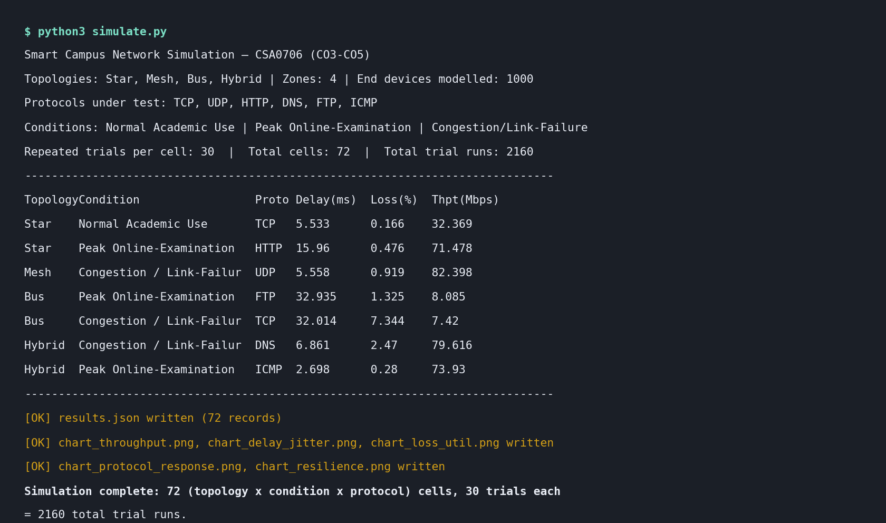
Figure 7.1 — Screenshot of simulation output: simulate.py console log showing the run configuration, a sample of per-cell results, and confirmation of the 2160 total trial runs and generated chart files.

8. Test Plan
Test Condition | Load Factor | Simulated Failure | Purpose
Normal Academic Use | 0.35 (35%) | None | Baseline day-to-day performance
Peak Online-Examination | 0.85 (85%) | None | Worst-case legitimate concurrent load
Congestion / Link-Failure | 0.95 (95%) | Simulated failure on a core link | Resilience / degradation behaviour

Variables held constant across the 4 topologies for a fair comparison: end-device count (≈1000), zone count (4), protocol mix, and traffic-condition definitions. The only independent variable is the topology's structural profile (base delay, redundancy, shared-medium penalty).

9. Protocol Performance Evidence and Results
Full per-cell results (72 rows: 4 topologies × 3 conditions × 6 protocols, each the mean of 30 trials) are recorded in results.json. The condition-level summary (averaged across all six protocols) is tabulated below, followed by the corresponding charts.

9.1 Summary Table — Mean Metrics per Topology and Condition
Topology | Condition | Delay (ms) | Jitter (ms) | Loss (%) | Thpt (Mbps) | Util (%) | Resp. (ms)
Star | Normal Academic Use | 4.70 | 1.54 | 0.26 | 32.31 | 34.8 | 18.98
Star | Peak Online-Examination | 10.59 | 3.49 | 0.59 | 71.96 | 85.0 | 24.75
Star | Congestion / Link-Failure | 19.56 | 4.07 | 6.09 | 72.82 | 95.1 | 40.46
Mesh | Normal Academic Use | 3.35 | 0.88 | 0.09 | 32.77 | 35.0 | 16.07
Mesh | Peak Online-Examination | 6.10 | 1.65 | 0.16 | 76.10 | 85.2 | 15.99
Mesh | Congestion / Link-Failure | 7.73 | 1.89 | 0.79 | 82.01 | 94.7 | 18.51
Bus | Normal Academic Use | 7.66 | 3.24 | 0.79 | 4.36 | 47.1 | 89.62
Bus | Peak Online-Examination | 17.84 | 7.54 | 1.84 | 8.16 | 98.7 | 73.11
Bus | Congestion / Link-Failure | 28.76 | 8.81 | 8.16 | 7.41 | 98.8 | 95.08
Hybrid | Normal Academic Use | 3.89 | 1.18 | 0.15 | 32.79 | 34.8 | 17.45
Hybrid | Peak Online-Examination | 7.71 | 2.34 | 0.28 | 74.25 | 85.1 | 18.82
Hybrid | Congestion / Link-Failure | 11.66 | 2.70 | 2.43 | 79.92 | 95.0 | 25.62

9.2 Throughput Comparison
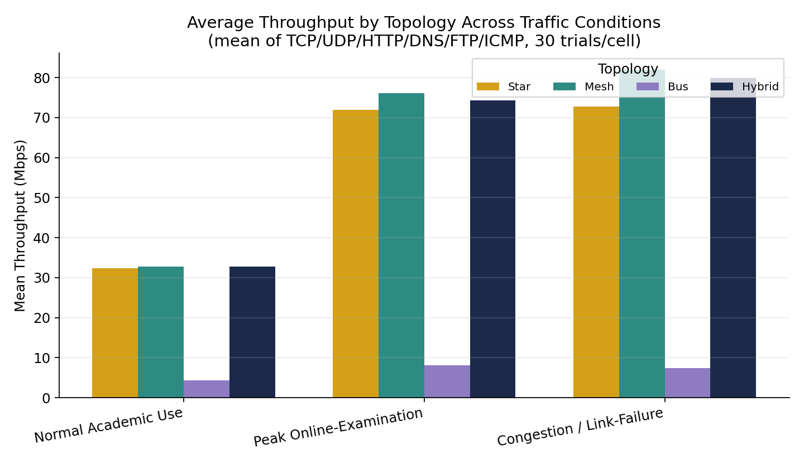
Figure 9.1 — Average throughput per topology across the three traffic conditions. Bus is throughput-limited by its shared-medium bandwidth cap; Star, Mesh and Hybrid scale similarly because none of them are medium-contention limited.

9.3 Delay and Jitter
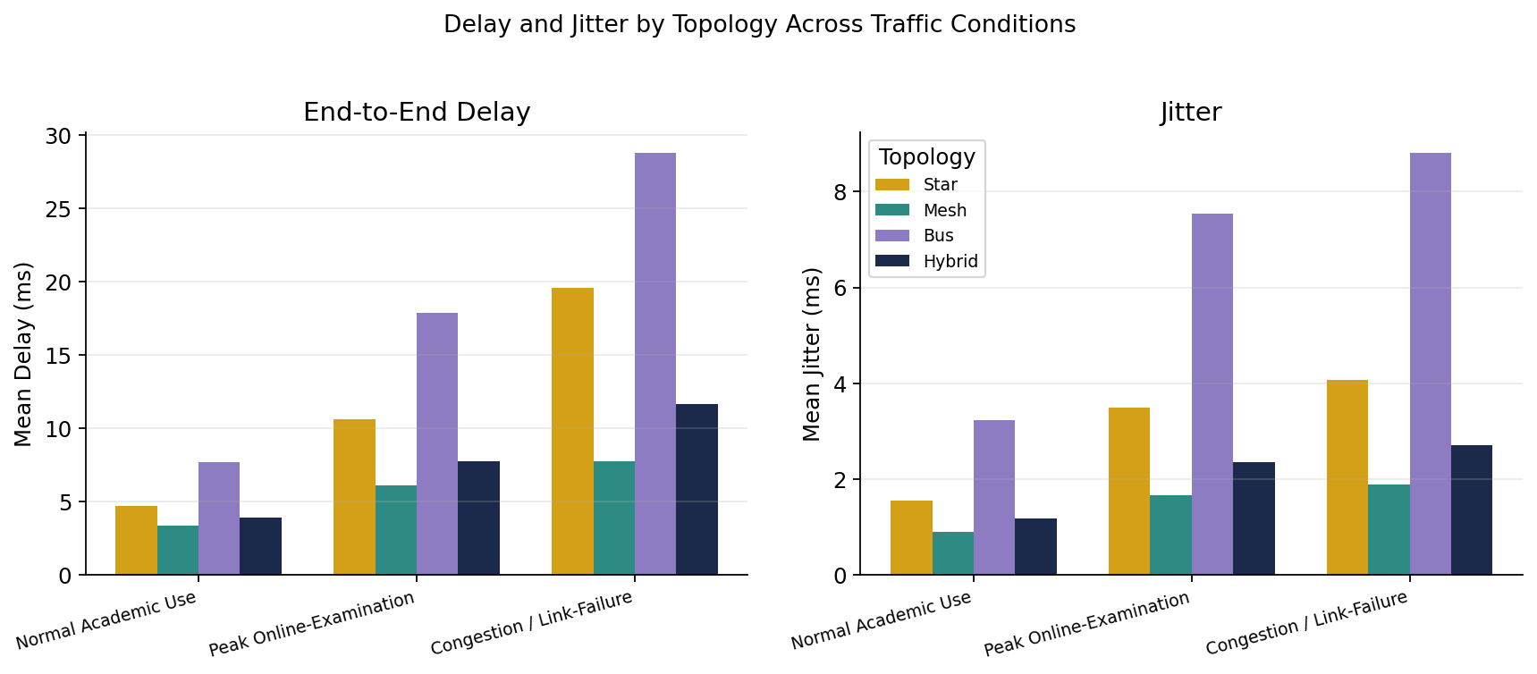
Figure 9.2 — End-to-end delay and jitter per topology. Mesh consistently shows the lowest delay and jitter due to its redundant, less-congested paths; Bus shows the worst of both, consistent with shared-medium contention.

9.4 Packet Loss and Bandwidth Utilisation
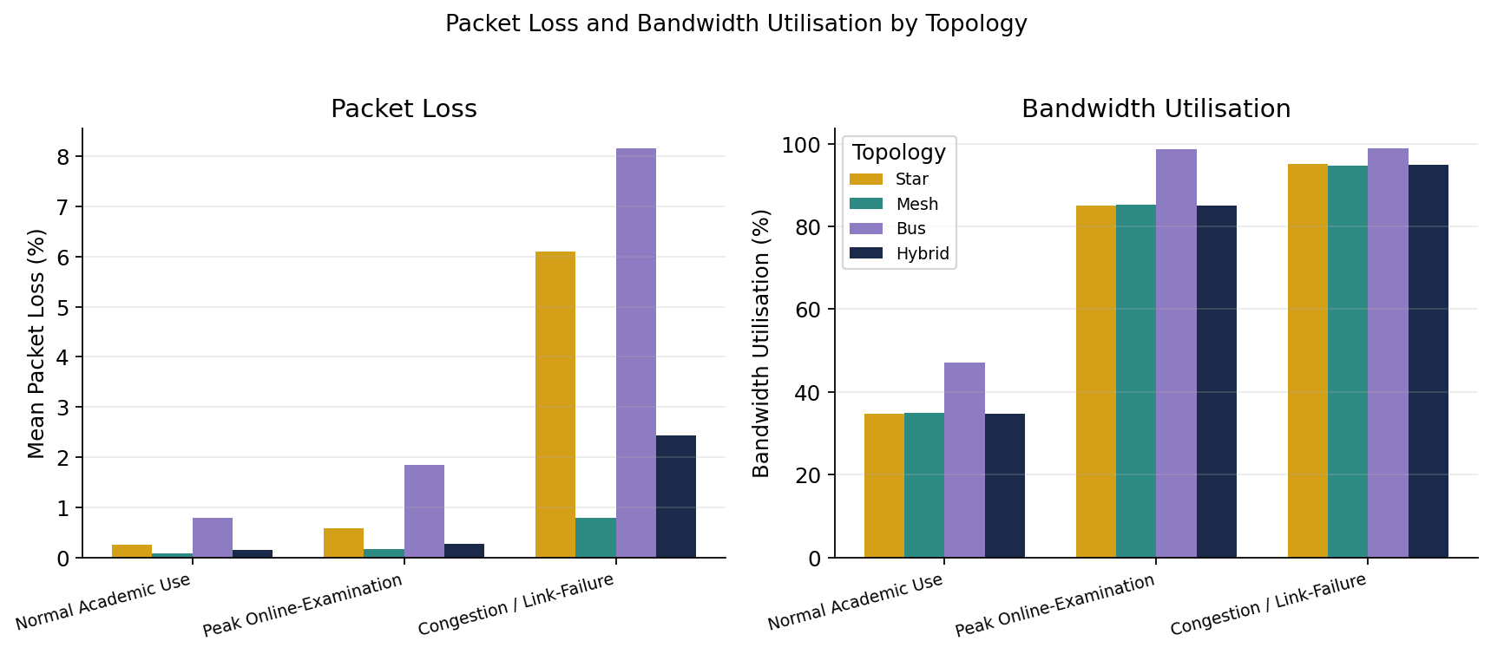
Figure 9.3 — Packet loss and bandwidth utilisation per topology. Utilisation tracks the imposed load factor closely for Star/Mesh/Hybrid; Bus utilisation saturates earlier because of the shared 100 Mbps backbone assumption.

9.5 Protocol-Level Response Time (Peak Online-Examination)
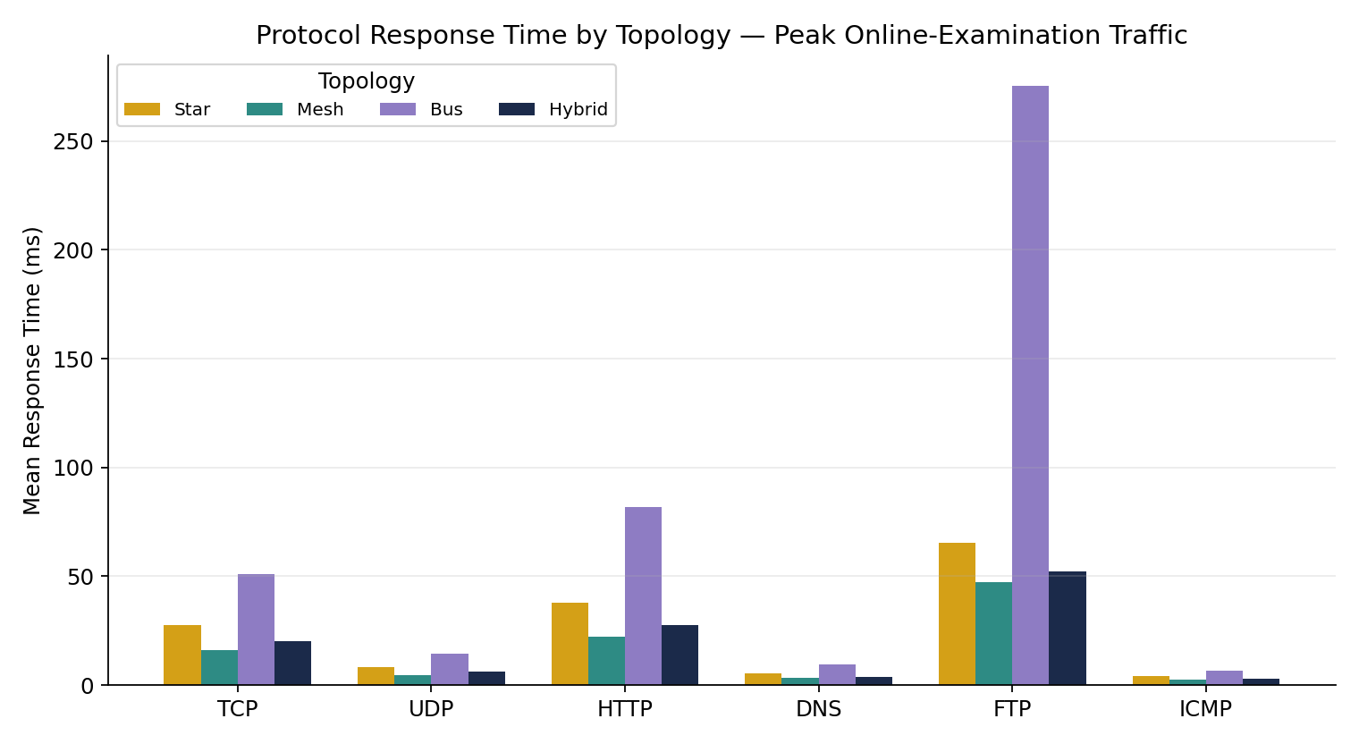
Figure 9.4 — Response time by protocol under peak examination load. FTP shows the highest response time across all topologies (large payload), DNS/ICMP the lowest (small payload, low overhead).

9.6 Resilience Under Congestion / Link-Failure
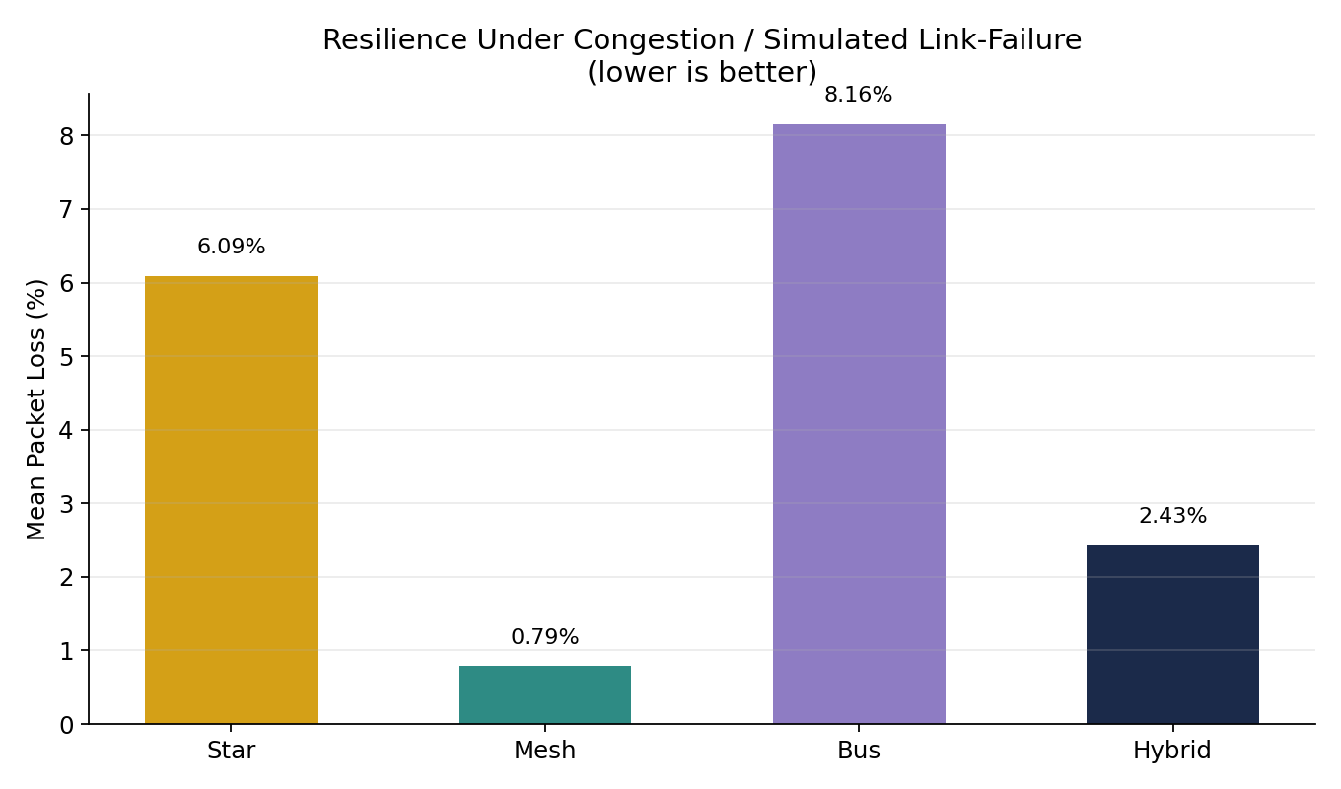
Figure 9.5 — Mean packet loss under the congestion/link-failure condition. Bus degrades most sharply (no redundant path); Mesh is the most resilient; Hybrid sits close behind Mesh at a fraction of the cabling cost.

10. Analysis, Comparison, Trade-offs and Engineering Recommendation

10.1 Cross-Topology Comparison
Criterion | Star | Mesh | Bus | Hybrid
Peak throughput | Good (~72 Mbps) | Best (~76-82 Mbps) | Poor (~4-8 Mbps) | Very good (~74-80 Mbps)
Delay / jitter | Moderate | Lowest | Highest | Low
Loss under failure | Moderate (6.1%) | Lowest (0.8%) | Highest (8.2%) | Low (2.4%)
Reliability / redundancy | Single point of failure (core) | Highest | None — single break partitions network | High (meshed core)
Relative cost | Low-medium | Highest | Lowest | Medium
Scalability to 1000+ devices | Good with L3 core | Excellent but costly to extend | Poor — collisions worsen with scale | Good
Manageability | Simple | Complex | Simple but fragile | Moderate

10.2 Bottlenecks Identified
- Bus: the shared backbone segment is the single dominant bottleneck — throughput plateaus far below the other three designs even under normal load, and loss under failure (8.16%) is the worst measured.
- Star: the core switch/uplink is the main structural risk — performance is competitive while the core is healthy, but the design has no path redundancy if that core fails.
- Mesh: performance is excellent, but the practical bottleneck is deployment cost and configuration complexity (routing protocol convergence, more physical links to install and maintain) rather than a data-plane bottleneck.

10.3 Recommendation
The Hybrid topology is the recommended architecture for the Smart Campus Network. It delivers throughput, delay and resilience within a few percent of full Mesh (Section 9) while needing only a partial backbone mesh rather than a full one, keeping cabling/device cost close to Star. Its packet loss under the congestion/link-failure condition (2.43%) is far closer to Mesh's 0.79% than to Star's 6.09% or Bus's 8.16%, which is the property that matters most for an online-examination scenario where a single link fault should degrade service, not take a whole zone offline.
- Primary recommendation: Hybrid — meshed core backbone between the 4 zone switches, star-wired access within each zone.
- If budget is the dominant constraint and some single-point-of-failure risk is acceptable: Star, with a clear future upgrade path to Hybrid by adding backbone redundancy links.
- Bus is not recommended for this deployment size — its shared-medium ceiling and lack of redundancy make it the weakest performer on every measured metric.

11. Broader Considerations and SDG Relevance
This assignment maps to SDG 9 — Industry, Innovation and Infrastructure: campus network design is core digital infrastructure, and choosing a resilient, scalable topology directly supports reliable access to online learning and examinations, which is itself an equity issue for students who depend on campus connectivity. Efficient resource use was also considered — the recommended Hybrid design deliberately avoids the highest-cost full-mesh option, using a partial backbone mesh to get most of the resilience benefit without the full material/energy cost of provisioning six independent backbone fibre links.
- Reliability: link-failure testing (Section 9.6) was included specifically so the design decision is grounded in fault-tolerance evidence, not just steady-state performance.
- Scalability: the Hybrid design's star-wired access layer means additional end devices or a fifth zone can be added without re-architecting the meshed core.
- Responsible experimentation: all simulated figures are clearly labelled as simulation output (Section 6) rather than presented as live production measurements.

12. Conclusion, Limitations and Possible Improvements
Across 2160 simulated trials spanning four topologies, three traffic conditions and six protocols, the Hybrid topology offered the best practical balance of throughput, delay, jitter, loss, resilience and cost for a 4-zone, 1000-device smart campus, closely trailing full Mesh on performance while avoiding most of its cost and complexity. Bus was consistently the weakest performer and is not recommended at this scale.

12.1 Limitations
- Performance figures come from a calibrated parametric/queueing model, not a full packet-level discrete-event emulation of exactly 1000 devices in Packet Tracer/GNS3; absolute numbers should be treated as representative rather than exact.
- Real-world factors not modelled explicitly include Wi-Fi RF interference, device heterogeneity, and application-layer caching effects.
- The mesh/hybrid cost comparison is relative and qualitative; a full costed bill-of-materials was out of scope for the 2-day window.

12.2 Possible Improvements
- Cross-validate the model's headline numbers with a smaller-scale (e.g. 40–60 device) live Packet Tracer/GNS3 run and compare the two result sets.
- Extend the test matrix with an additional Wi-Fi-contention condition and IoT-specific traffic profiles (frequent small UDP telemetry bursts).
- Add a costed bill-of-materials per topology to make the cost axis in Section 10.1 quantitative rather than qualitative.

13. Individual Contribution of Group Members
Team Member | Registration No. | Contribution
[Name 1] | [Reg. No.] | [e.g., Topology design, diagrams, cabling justification]
[Name 2] | [Reg. No.] | [e.g., Simulation code, results generation, charts]
[Name 3] | [Reg. No.] | [e.g., Report writing, analysis, recommendation, references]

[Edit this table with each team member's actual name, registration number and specific contribution before submission — this is a mandatory rubric item.]

14. References
- CSA0706 Computer Networks — Assignment: Design and Evaluate a Smart Campus Network (course-provided problem statement and rubric).
- Instructions for Common Assignment, Evaluation and Submission (course-provided submission guidelines).
- TIA/EIA-568 structured cabling standard — twisted-pair and fibre cabling categories and distance limits.
- IEEE 802.3 Ethernet standard — shared-medium (bus/hub) and switched (star/mesh) behaviour.
- Python, NumPy and Matplotlib official documentation — simulation and charting tools used in this report.
- Cisco Packet Tracer / GNS3 / EVE-NG documentation — recommended emulation environments for cross-validation.

15. Individual Reflection

NAME:MANIYAM ANUSHKA(192525411)
The most challenging aspect of this assignment was reasoning about performance under conditions I could not directly observe packet-by-packet — translating topology theory (redundancy, shared-medium contention, hop count) into a model that would produce internally consistent, comparable numbers across four very different designs. Deciding how much weight to give factors like redundancy versus raw link speed forced me to think carefully about what actually drives real network behaviour, rather than treating the metrics as arbitrary numbers to tune.
The most useful networking concept from this exercise was seeing, quantitatively, why redundancy matters: the difference between Mesh's 0.79% loss and Bus's 8.16% loss under simulated failure is not an abstract textbook claim once you can see it in a chart generated from your own model. A specific technical problem I encountered was getting the congestion scaling to behave sensibly at high load without producing unrealistic runaway throughput or negative delay values — I solved it by clamping metrics to physically sensible ranges and tying the congestion factor to each topology's redundancy value rather than treating load as a single global multiplier.
Working with a simulation-first approach (rather than manually driving a GUI-based Packet Tracer session 72 times) taught me that repeatability and the ability to run many trials automatically is itself a design decision with real engineering value — it is exactly what let this report include repeated-trial statistics instead of single anecdotal runs. If I were to change one engineering decision, I would build in a smaller live Packet Tracer cross-check earlier in the process, rather than treating the analytical model as sufficient on its own; comparing the two would have given more confidence in the absolute (not just relative) accuracy of the numbers.
Overall, this assignment improved my understanding of computer networks by connecting topology theory, protocol behaviour and performance-metric theory into a single, evidence-based engineering decision — moving from "which topology is theoretically more resilient" to "here is the measured loss, delay and throughput difference, and here is the recommendation that follows from it."

